** Document Version Information

Document Version Information
Version | Description of Changes | Date | Author
0.1 | Hello world. Initial Draft | 8/24/05 | Betsey West
1.0 | First complete draft | 9/6/05 | Betsey West

Document Scope
This document is specific to Iteration 2 of the MK Factory. It covers information relevant to that release only. Details of Demand Prioritization, Error Reporting and Tracking and the FWO Queue are covered in other documents.

Introduction
This document details the functional and technical requirements, high-level architecture and process flow related to the production of Process Plans for MK Infoscan. It will be used by the development team during the creation of the detailed design documents and is also intended to be used for the development of test cases.

Level of Detail in this Document

This specification captures our best, current understanding of data, flow and functionality. As a living document, it will need to be revised as that understanding grows. It captures our understanding of the issues as of this moment in time. This piece of the system is being actively designed at the time of this writing, and this document, if not updated could become out of date very quickly.

Overview of the Process Plan Document

Process Plan: What does it do?
In the context of this project, a process plan is an xml document that describes all the information and procedures required to create a datamart. The process plan is the recipe that describes the product to be delivered in a completed state by the factory’s operation. It defines and describes the tools, information and steps required to create a datamart or a part of a datamart.
The process plan does not implement any of the specific functionality required by the Delivery Management Use Cases. Please see the <insert document name here> for an overview of that functionality.
This important component of the factory’s operation is created automatically by a process plan creation mechanism. While the OMS system provides the functionality to review and modify the specifications for an individual delivery, what the user is modifying is not the process plan. Delivery functionality is not discussed in this document. Please see the External Design document for Demand Prioritization and Deliveries for this information. The process plan sets out the requirements for the creation of the delivery Process Plans have no user interface component and very little (or no) human intervention in their creation.
As conceived by the OMS team, the process plan has 5 logical sections:
- Extraction
- Aggregation
- Db Load
- AS model
- Visualization

The process plan is created after data availability and releasability have been determined by the Inventory Management module. Process Plans should not be created for BOMs that fail either of these previous checks.

From Order to DataMart: A Deliverable’s Journey
This section will describe the mechanism by which an order, over time, flows through the OMS system, is instantiated and eventually enters the factory as a process plan. This is intended as an overview and is very high-level.
The process begins with the order taker. That individual, working with a customer, fills out a form in the OMS system, thus defining a “package” sold to a customer to deliver a particular data set to that customer. That data set is to be refreshed at specified periods for the life of the order. Details of this business flow, data to be captured, and user roles can be found in the “Create an Order” Use Cases.
A scheduling mechanism, yet to be defined (see Demand Prioritization, below), wakes up and scans the open, active orders to determine which orders are scheduled to run and creates a Bill of Material for each deliverable (data mart) within the order (note: orders can contain nested orders). One order may require a data set refresh (or creation). One or more BoM’s are created for each order, with one BoM (Bill of Material) record being created for each output datatype (Consumer/Panel, POS/Infoscan, or Market Insight) included on the order. This is implemented by the Create_BoM service, not covered in this document. BoMs are written to the BoM DB upon creation. (For i2, the scheduling engine is not implemented. A single BoM will be created automatically when the order is committed.)
The scheduling mechanism next triggers two separate validation checks on each BoM before moving forward with creating the Process Plans (one per BoM). Inventory Management is called to perform data availability and releasability checks. Using the high-level (key) definitions of items, measures, and venues (stored in the LOP database), IM (the Inventory Manager) resolves all of the dimensional and measure keys by making calls to DMS (Dimensional Mgmt System) and MAT (Measure Authoring Tool) systems to select the data required to make the checks. Availability and releasability rules are created in BRMS. BoMs records are updated in the BoMdb to capture success/failure. (For i2, this step will be skipped.)
Once the BoM passes validation, the scheduling service initiates the service to create the Process Plan. (For i2, this will be initiated from a button on the Delivery screen.)

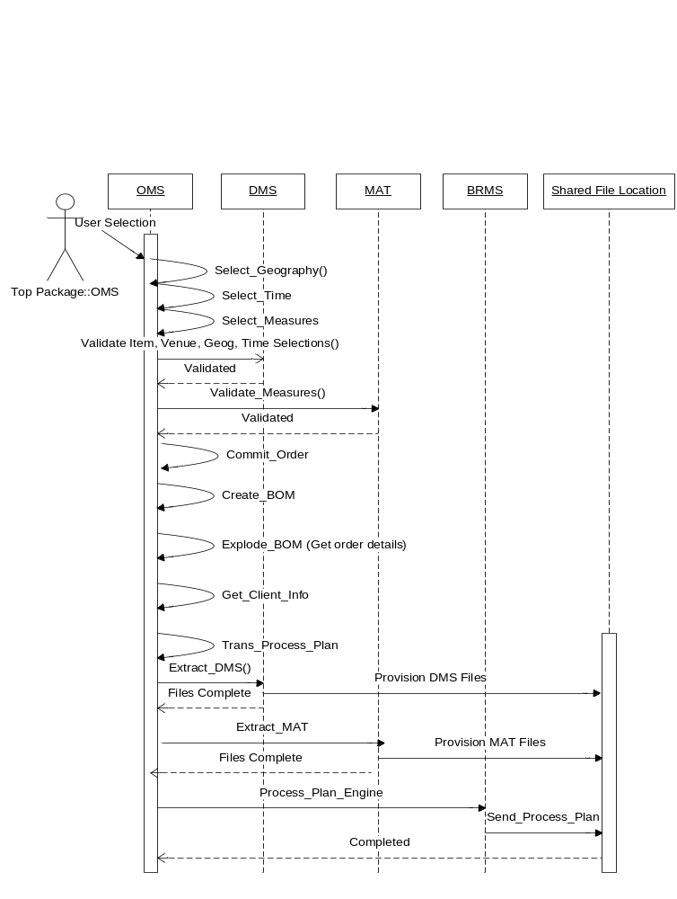

Figure 1. Iteration 2 Sequence Diagram

The Process Plan creation begins with the triggering of a service (Explode_Bom) that selects order details from the Orderdb. The service will select information such as the top-level product(s) this deliverable relates to, the measures to be included, content start date, content end-date, etc. This service populates the top level of information for this delivery.
Next, the scheduler (Demand Prioritization Engine = DPE) will call the Transaction_Process_Plan service to trigger Process Plan creation for the BoM. Transaction_process_Plan is a transaction service that calls a number of other subordinate services to select and reason about information required to create the process plan.

Client Setup
The first step that Transaction_Process_Plan takes is to call the Get_Client_Info service to select client-specific information required to generate the datamart. This information is used by downstream processes to understand where to place the results of that system’s processing as the “datamart” moves through the factory. (e.g., DMC needs to know the host, port, db name, password in order to place the aggregated result sets into the correct database instance). <Ursula, what’s the reason behind the client-type here?>

The long-term vision for how this will be accomplished is that client information will be periodically extracted from the Siebel (CAM) system and stored in the List of Parts in the same way that MAT and DMS information will be stored. The processes for selecting and maintaining this information have not yet been defined. (for i2, the information will be hard-coded and stored in the LOP.)
<CLIENT_ID>111</CLIENT_ID>
<CLIENT_NAME>IRI-I2</CLIENT_NAME>
<CLIENT_TYPE>RETAILER</CLIENT_TYPE>
<DB_HOST>hpdev2</DB_HOST>
<DB_SERVER>bbdm3dbd</DB_SERVER>
<<DB_PORT>12345</DB_PORT>
<<DB_NAME>pepsi</DB_NAME>
<<DB_PASSWORD>pwd</DB_PASSWORD>
<<AS_HOST>platdev22</AS_HOST>
<<AS_PORT>12345</AS_PORT>
<<AS_USER>superuser</AS_USER>
<<AS_PASSWORD>pwd</AS_PASSWORD

Figure 2. Client-specific data

Unique Identifier
Next, the Trans_Process_Plan service generates the unique process plan identifier, the pplanid. This is done by means of a database sequence. <Tom, will this be done by a service? Do we have a definition for it?>

Seed File Extraction
In order for the delivery to be processed through the factory, detailed information (often referred to as leaf-level data) about the items, venues and measures to be contained in a delivery must be provided to guide the process that will select the fact rows for the datamart. Since OMS only stores the top-level keys required to drive the user interface at order-creation time, these details must be selected from their hosting applications to provide direction to Harvester. This is accomplished by requesting that data from the DMS (item and venue) and MAT (measures) applications be written to a location accessible by Harvester in a flat-file format.

This is accomplished by two service calls for the batch creation of several files (See Appendix B: Service Definitions, below for detailed description of these services).

OMS initiates a service call (Extract_DMS) to DMS to create 9 extract files (for each BoM) and place them on the DMZ. OMS will make one request to DMS service for venue, Item and Time information. Here is a break down of the input and output of the DMS service.

INPUT

<CATEGORY_KEY>1828283</CATEGORY_KEY>
<VENUE_GROUP_LIST>
<VENUE_GROUP_KEY>83838</VENUE_GROUP_KEY>
<VENUE_GROUP_KEY>83838</VENUE_GROUP_KEY>
…
</VENUE_GROUP_LIST>
<AS_OF_DATE></AS_OF_DATE>
<FILE_PREFIX>123.1.DIM</FILE_PREFIX>
<OUT_FILE_LOCATION>
<FTP_SERVER>iriftp.corp.acxiom.net</FTP_SERVER>
<FTP_ID>test-id</FTP_ID>
<FTP_PSW>password</FPT_PSW>
<PATH>/iri/infoscan_mk/</PATH>
</OUT_FILE_LOCATION>

OUTPUT

<DIMENSION type=”ITEM”>
<LEAF_LEVEL_KEYS>123.1.DIM.ITEM.KEYS</LEAF_LEVEL_KEYS>
<DUAL_KEY_FILE_LIST>
<DUAL_KEY_FILE>123.1.DIM.ITEM.HIERARCHY.38383</DUAL_KEY_FILE>
…
<DUAL_KEY_FILE_LIST>
<META_FILE_LIST>
<META_FILE>123.1.DIM.ITEM.META.383838</META_FILE>
…
</META_FILE_LIST>
<DIMENSION>
<DIMENSION type=”VENUE”>
<LEAF_LEVEL_KEYS>123.1.DIM.VENUE.KEYS</LEAF_LEVEL_KEYS>
<DUAL_KEY_FILE_LIST>
<DUAL_KEY_FILE>123.1.DIM.VENUE.HIERARCHY.38383</DUAL_KEY_FILE>
…
<DUAL_KEY_FILE_LIST>
<META_FILE_LIST>
<META_FILE>123.1.DIM.VENUE.META.383838</META_FILE>
…
</META_FILE_LIST>
<DIMENSION>
<DIMENSION type=”TIME”>
<LEAF_LEVEL_KEYS>123.1.DIM.TIME.KEYS</LEAF_LEVEL_KEYS>
<DUAL_KEY_FILE_LIST>
<DUAL_KEY_FILE>123.1.DIM.TIME.HIERARCHY.38383</DUAL_KEY_FILE>
…
<DUAL_KEY_FILE_LIST>
<META_FILE_LIST>
<META_FILE>123.1.DIM.TIME.META.383838</META_FILE>
…
</META_FILE_LIST>
<DIMENSION>

Trans_Process_Plan will call an MAT service (Extract_MAT) passing in an XML document (see sample below). MAT will create a set of files on the ftp server and send back an XML document in the provided format. (see sample XML response below) MAT files produced based on list of measures provided

File create are:
<pplanid>.<generation>.DIM.MEAS.FACT (contains the fact file information that needs to be pulled form FDW. Will only be used for I2)
<pplanid>.<generation>.DIM.MEAS.DETAIL (contains aggregation detail on measures)
<pplanid>.<generation>.DIM.MEAS.ASMODEL (contains information on measures required by AS MODEL)

<pplanid>.<generation>.DIM.MEAS.WEIGHTS.DATA (just for I2)
<pplanid>.<generation>.DIM.MEAS.WEIGHTS.META (just for I2)
<pplanid>.<generation>.DIM.MEAS.ACV.DATA (just for I2)
<pplanid>.<generation>.DIM.MEAS.ACV.META (just for I2)
<pplanid>.<generation>.DIM.MEAS.STORECOUNT.DATA (just for I2)
<pplanid>.<generation>.DIM.MEAS.STORECOUNT.META (just for I2)
<pplanid>.<generation>.DIM.MEAS.MOVEMENT.META (just for I2)

INPUT SAMPLE

<AS_OF_DATE>2005-9-2</AS_OF_DATE>
<FILE_PREFIX>123.1.DIM</FILE_PREFIX>
<OUT_FILE_LOCATION>
<FTP_SERVER>iriftp.corp.acxiom.net</FTP_SERVER>
<FTP_ID>test-id</FTP_ID>
<FTP_PSW>password</FPT_PSW>
<PATH>/iri/infoscan_mk/</PATH>
</OUT_FILE_LOCATION>
<MEASURE_LIST>
<MEASURE>SampleMeasure1Key</MEASURE>
<MEASURE>SampleMeasure2Key</MEASURE>
<MEASURE>SampleMeasure3Key</MEASURE>
<MEASURE>SampleMeasure4Key</MEASURE>
</MEASURE_LIST>

XML response from Service call will list the files that have been created with the provided prefix. Note for the highlighted file MAT is only providing the name of the file. This file will be produced by extraction section of the process plan. The rest you will be provide on the ftp server by MAT.

<FILE_LIST>
<EXTRACTION_FILE>123.1.DIM.MEAS.FACTS</EXTRACTION_FILE>
<AGGREGATION_FILE>123.1.DIM.MEAS.DETAIL</ AGGREGATION_FILE >
<ASMODEL_FILE>123.1.DIM.MEAS.ASMODEL</ASMODEL_FILE >
<MOVEMENT>
<DATA_FILE>123.1.MOVEMENT.DATA</DATA_FILE>
<META_FILE>123.1.MOVEMENT.META</META_FILE>
</MOVEMENT>
<PROJECTION_FILES>
<ACV>
<DATA_FILE>123.1.DIM.MEAS.ACV.META</DATA_FILE>
<META_FILE>123.1.DIM.MEAS.ACV.META</META_FILE>
</ACV>
<STORECOUNT>
<DATA>123.1.DIM.MEAS.STORECOUNT.META</DATA>
<META>123.1.DIM.MEAS.STORECOUNT.META</META>
</STORECOUNT>
<WEIGHTS>
<DATA_FILE>123.1.DIM.MEAS.WEIGHTS.META</DATA_FILE>
<META_FILE>.1.DIM.MEAS.WEIGHTS.META</META_FILE>
</WEIGHTS>
</PROJECTION_FILES>
</FILE_LIST>

OUTPUT FILE SAMPLE (file_prefix.DIM.MEAS.FACTS) Not used for I2
<FACT_FILE name=”123.1.FACT.DATA.1”>
<DIMENSIONALITY>
<DIMENSION >VENUE</DIMENSION>
<DIMENSION >TIME</DIMENSION>
</DIMENSIONALITY>
<FACTS>
<FACT>Fact1Key</FACT>
<FACT>Fact2Key</FACT>
</FACTS>
</FACT_FILE>
<FACT_FILE id=”123.1.FACT.DATA.2”>
<DIMENSIONALITY>
<DIMENSION >ITEM</DIMENSION>
<DIMENSION >VENUE</DIMENSION>
<DIMENSION >TIME</DIMENSION>
</DIMENSIONALITY>
<FACTS>
<FACT>Fact3Key</FACT>
<FACT>Fact4Key</FACT>
</FACTS>
</FACT_FILE>

These Files are written by the called applications (DMS and MAT) to a common DMZ location (for i2, it will be an ftp server) between OMS and the Factory Grid by their hosting applications (MAT and DMS).

Process Plan Engine

On receiving confirmation from MAT and DMS that the files have been sent to the common area of the ftp site, Trans_Process_Plan invokes an embedded rule engine called Process Plan Engine. This engine, implemented in BRMS, will require the completion of the Business Object Model, as the operation of BRMS is dependent on that model.

The Process Plan Engine will be called to concurrently generate the 5 sections of the process plan. We are still working to determine whether there are any data dependencies inside the sections of the process plan that would prevent them from being generated concurrently.

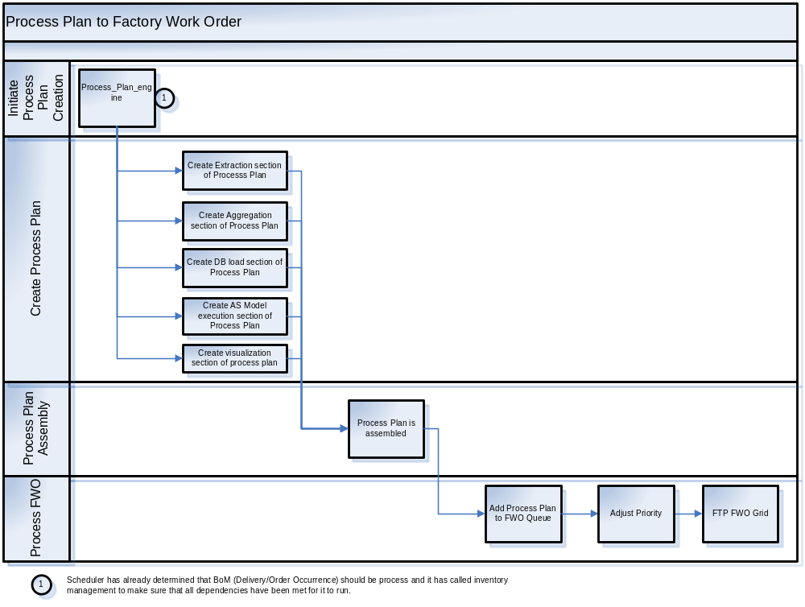

Figure 3. Assembling the Process Plan

The process plan will be assembled from the results of the Process Plan Engine’s work, the client details, and the sequence number. An xml document is written in the FWO Queue for the Process Plan using a unique key (Process_PlanId). (For i2, there will be no FWO Queue. Process plans will be written directly to the ftp site as xml documents. None of the steps in the FWO lane of the above document will be undertaken in i2) Details of the 5 sections of the process plan are covered individually below.

The Process Plan is written to a Process Plan Database.

The Factory

Once the Process Plan file and its subordinate files have all arrived on the ftp site, the grid will begin to act on them to create the datamart.

A job scheduling system, called Orbiter, “notices” that a new job has arrived in the ftp queue. (For i2, the arrival of the process plan file in the shared location triggers the factory to begin its processing.) The process plan xml document is broken up into smaller bits that are written to individual files and are used by the various factory subsystems as job control files. We envision this to be done using an XML Stylesheet (XST) to perform the translation. Once the set of control files is created, Harvester is called. Harvester is the factory component that selects the individual fact elements from the FDW (factory data warehouse) to be fed to the aggregation engine. Harvester will remove duplicates from the leaf-level key files that have been staged to the DMZ. Harvester will use the information contained in the previously staged files (in the DMZ) to select the proper Fact Data from FDW (for each BoM) and land it in a pre-determined location (using the data contained in the Extraction section of the process plan).

The DMC parser will read the Process Plan section for Aggregation and generate a control file which will be used to invoke the DMC engine (c++ engine called by DataStage) to build the data mart.

Upon completion of the Data Mart, DataStage will load the data mart into the Client DB using the dbLoad information provided in the Process Plan. At this point, the datamart exits from the grid and moves into another location to continue processing.

DMC Manager will then trigger the AS Model to run and rebuild the “Companion” (meta model) for the client’s data so it can be accessed by RPM or PlusSuite (Visualization section of the Process Plan). The datamart is then written to the final location from which it will be accessed by the customer.

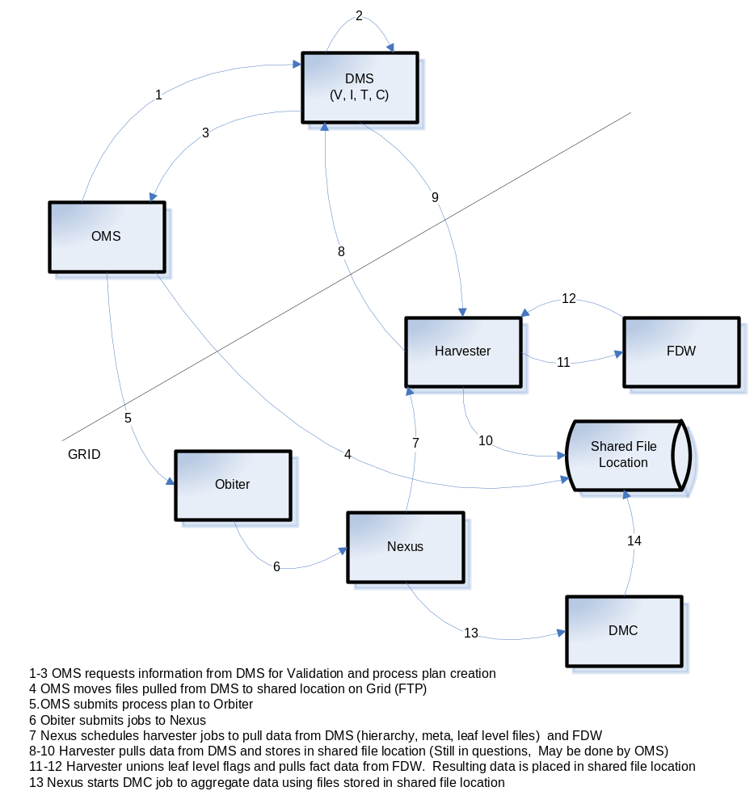

Figure 4. The Factory

Process Plan Sections
This section contains detail on the creation of each of the sections of the process plan.

Extraction

The extraction section contains the information required to select the fact movement data from the Factory Data Warehouse (FDW). Included in the process plan are the names (references) to the files created in previous steps to guide Harvester in data extraction. For i2 only, the extraction section will also directly select one of the fact data files for MAT. <Tom. I don’t understand this>

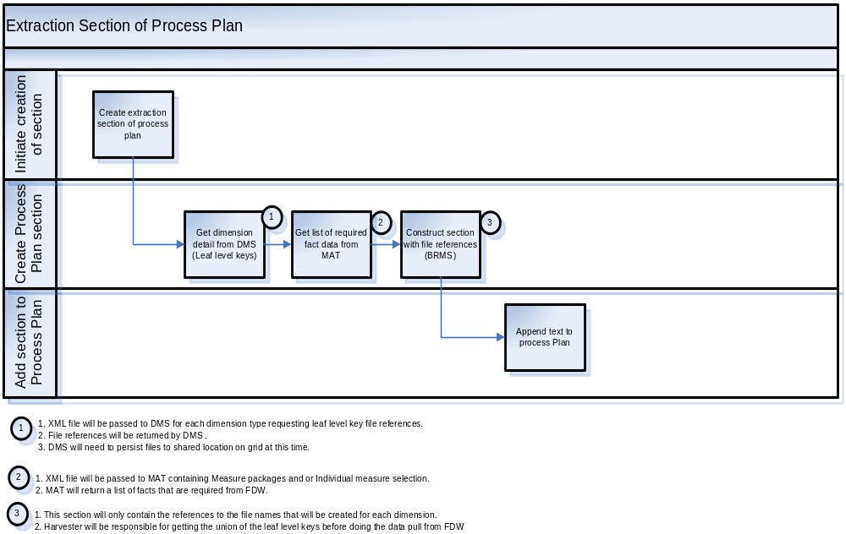

Aggregation

This section of the process plan contains details about how the aggregation of the data selected in the previous step is to occur. It contains references to the files created by the extraction services and also references to the fact movement data files created by the extraction section. The process plan is updated by the extraction step (in the factory) to include the references to the FDW data fles.

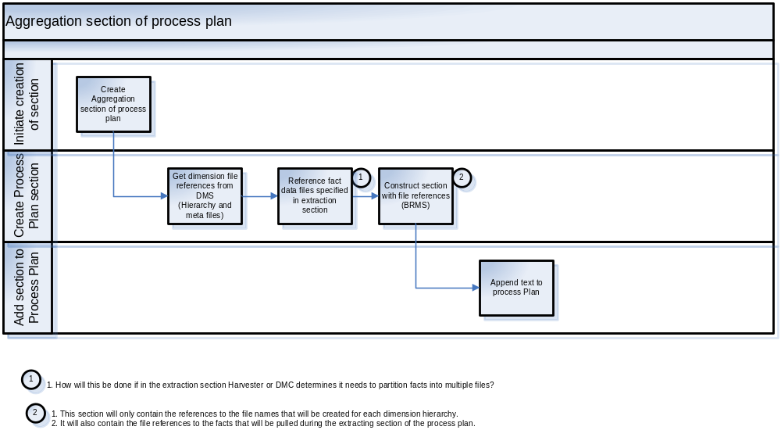

Database Load

The database loading section contains client specific information about how and where to stage the datamart created in the aggregation section. It would be in this step in the factory process in which the client-specific information captured in Figure 1 would be used.

<CLIENT_NAME>IRI-I2</CLIENT_NAME>
<DB_HOST>hpdev2</DB_HOST>
<DB_SERVER>bbdm3dbd</DB_SERVER>
<<DB_PORT>12345</DB_PORT>
<<DB_NAME>pepsi</DB_NAME>
<<DB_PASSWORD>pwd</DB_PASSWORD>

AS Model

This section would contain client specific information about how to build the AS Model. For a deliverable that was not an interactive datamart, this section would be absent. (For i2 the scope is a single POS deliverable, which would require this section to be present

<<AS_HOST>platdev22</AS_HOST>
<<AS_PORT>12345</AS_PORT>
<<AS_USER>superuser</AS_USER>
<<AS_PASSWORD>pwd</AS_PASSWORD

Visualization

This section contains any required instructions to rebuild the “Companion” (meta model) for the client’s data so it can be accessed by RPM or PlusSuite

Appendix A: File Naming Convention
Below is the file naming convention we propose.
<pplanid> = process plan “name”. Numeric generated by a db sequence
<generation> = 1,n, depending on how many times the pp has been executed
<key> = specific key referenced within the file
<pplanid>.<generation>.dim.venue.keys = venue leaf level data file
<pplanid>.<generation>.dim.venue.Hier.<key> = venue “hierarchy” (venue group), one file for each key provided in leaf data file
<pplanid>.<generation>.dim.venu.meta.<key> = venue metadata file (venue group), one file for each key provided in leaf data file
<pplanid>.<generation>.dim.item.<keys> = item leaf level data file
<pplanid>.<generation>.dim.item.Hier.<key> = item hierarchy, one file for each key provided in leaf data file
<pplanid>.<generation>.dim.item.meta.<key> = item metatdata file, one file for each key provided in leaf data file
<pplanid>.<generation>.dim.time.keys = time leaf level data file
<pplanid>.<generation>.dim.time.hier.<key> = time hierarchy, one file for each key provided in leaf data file
<pplanid>.<generation>.dim.time.meta.<key> = time metadata, one file for each key provided in leaf data file

<pplanid>.<generation>.dim.meas.facts =
<pplanid>.<generation>.dim.meas.detail =
<pplanid>.<generation>.dim.meas.asmodel =

<pplanid>.<generation>.processplan = the process plan file
<pplanid>.<generation>.fact.data.<number> = a data file extracted by harvester for a <pplanid>. Number is 1,n where there are n fact files extracted.

